Final Exam
Scenario No: 1
1. Create a directory: Final_exam
reports, tools, Backup, notes
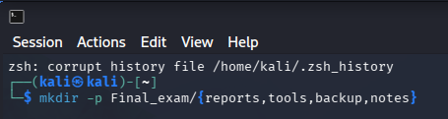
2.
Folder open and Script File create:
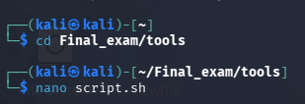
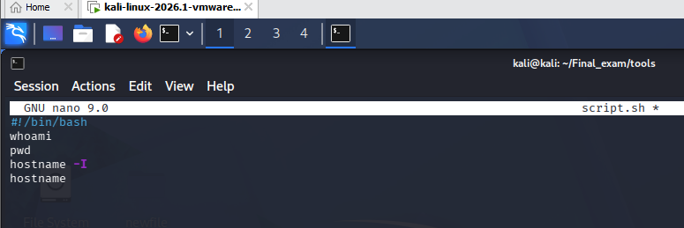
Run script then output save:
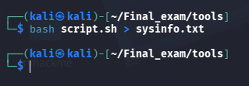
3. File Move and Rename:
Ls .. :file name check
File move and rename :
mv sysinfo.txt ../backup/backup_of_sysinfo.txt
Check file : ls ../backup
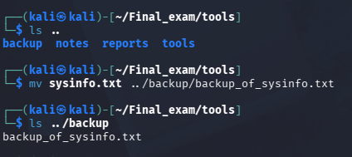
4. Delete the tools directory
Final_exam folder back: cd ..
Folder Delete : rm -rf tools
Check: ls
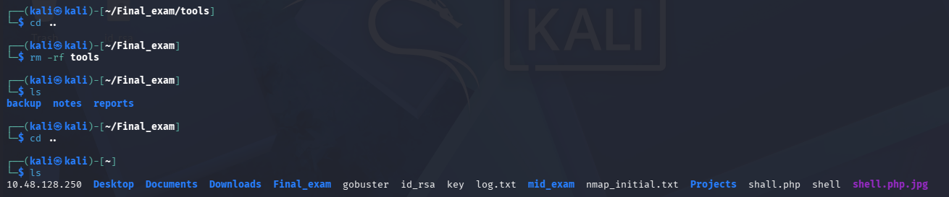
5. Create a new user named john
set a password for the use
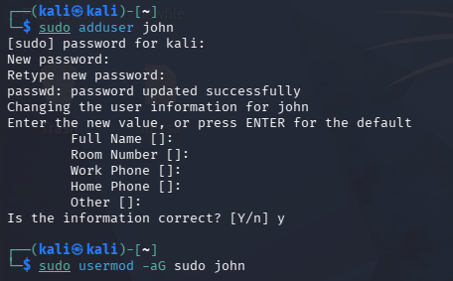
add the user to the sudo group.
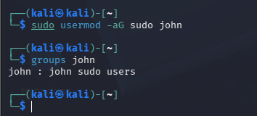
Here john sudo users
Scenerio 2:
1.
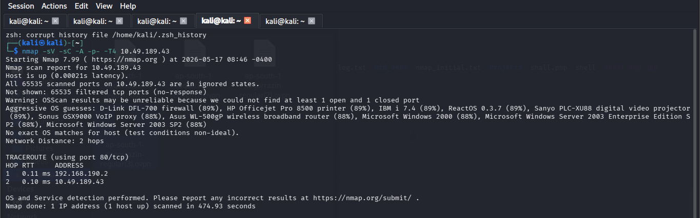
2.
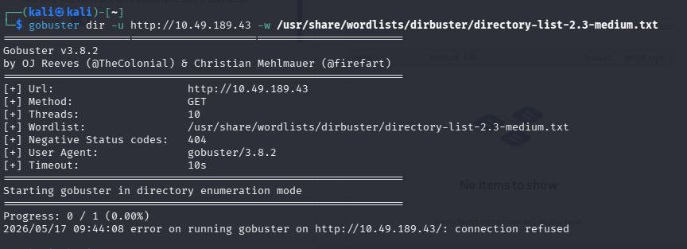
Sc 3:
1.

Port scan
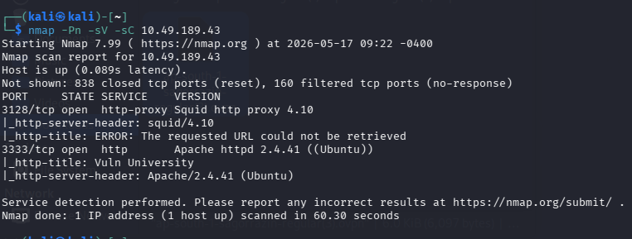
Hidden directory
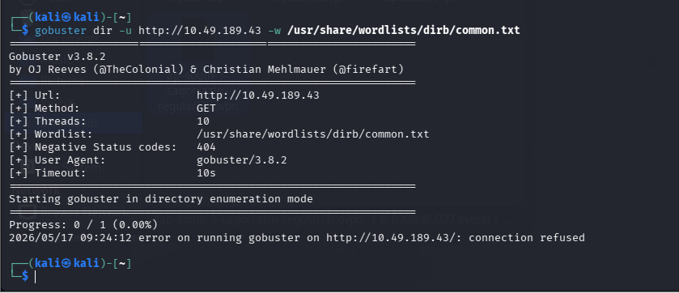

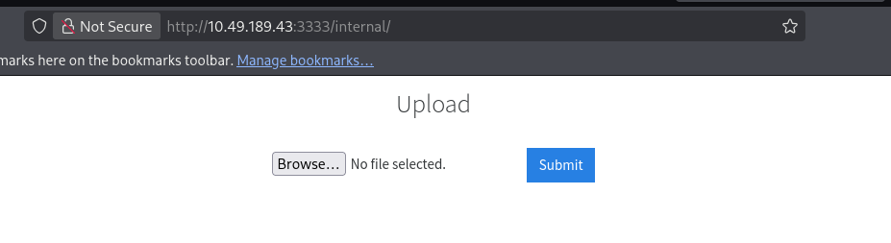
2.
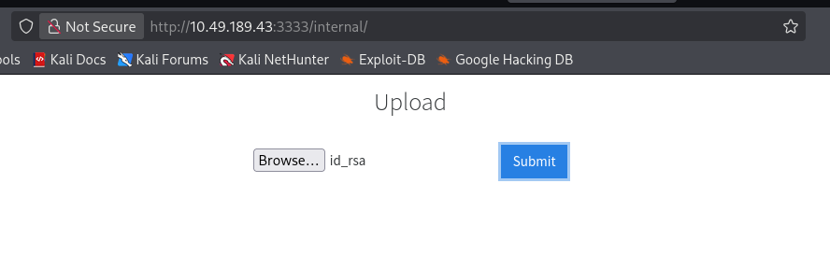
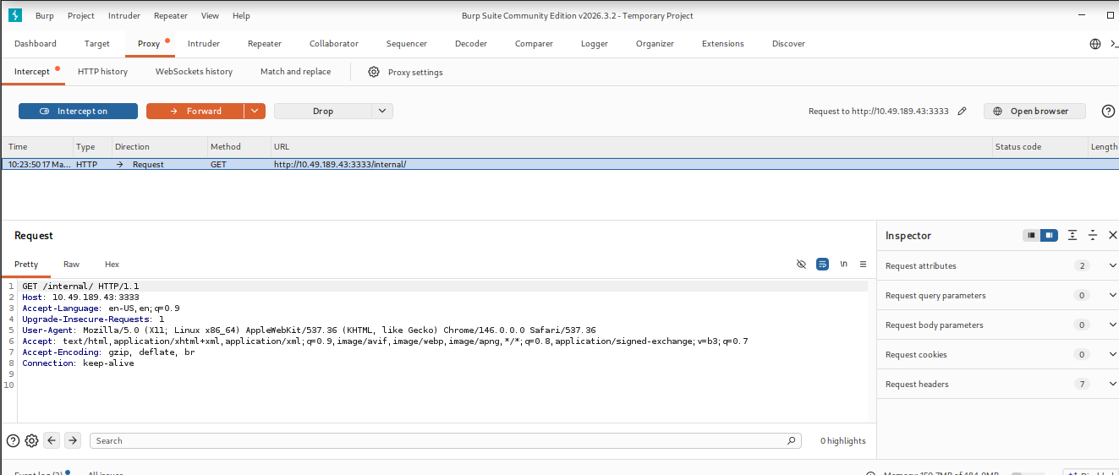

3.
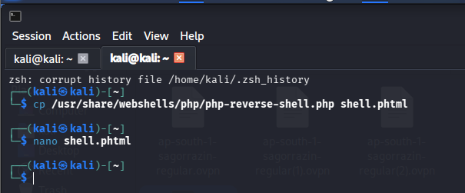
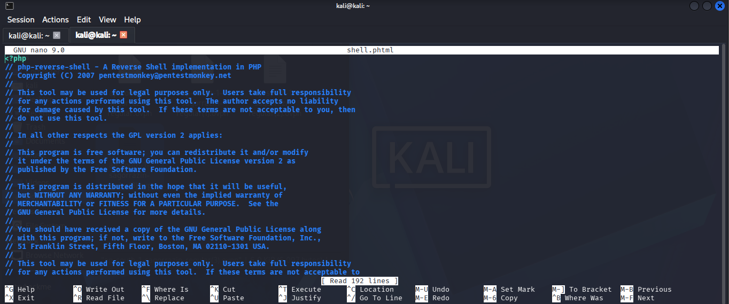
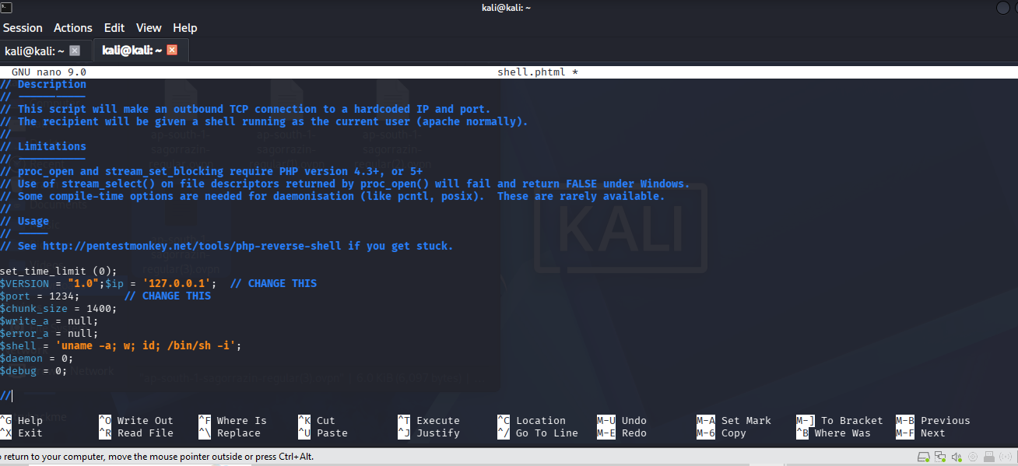
Reverse shell:
http://10.49.189.43:3333/internal/uploads/shell.phtml
Flag Read: cat /home/bill/user.txt
Scenario No: 4

Executive Summary
1
The Linux user environment was successfully configured according to organizational requirements. Proper directory management and user privilege configuration reduce administrative errors and improve system organization with a Low Risk impact.
2
Multiple active network services and hidden web directories were identified during reconnaissance. Some exposed services and accessible directories may provide attackers with information useful for further attacks, creating a Medium Risk to the organization.
3
A file upload vulnerability was successfully exploited to gain remote access to the target machine. This demonstrates a Critical Risk, as attackers could potentially compromise systems, execute commands remotely, and access sensitive information.

